ADVANCED FALL&VITALS ALERT SYSTEM
PROJECT REPORT
MALAVIKA KR 25BOE10137

INTRODUCTION
This project outlines the development of a wearable, real-time patient monitoring system designed to automatically detect and respond to medical emergencies, specifically focusing on patient falls.
The system utilizes an accelerometer to constantly analyze the
patient's motion and a heart rate sensor to assess their physiological state. The core objective is to minimize the time between a critical event (a fall) and the commencement of emergency aid.

PROBLEM STATEMENT

The core problem is the critical delay and poor reliability inherent in current fall alert systems for at-risk individuals.
Falls are major injury causes, but existing systems either
fail to notify if the patient is incapacitated (the long-lie problem) or generate too many false alarms, wasting caregiver time.

FUNCTIONAL REQUIREMENTS

Detect Impact: Trigger on >=2.5G
Confirm Fall: >=10 seconds stillness (=<0.2G). Check Pulse: Wait 3s. Alert if < 50 or >20 BPM.
Notify: Send alert on confirmation/
critical pulse
set is_patient_safe to FALSE.

NON FUNCTIONAL REQUIREMENTS

Performance: Real-time data processing (< 100 ms latency).
Reliability: High accuracy (>= 95% TPR, =<1% FPR).
Availability: High uptime (99.9%).
Security: Data encryption (HIPAA/GDPR) and access authentication.
Constraint: Battery life >=24 hours.

SYSTEM ARCHITECTURE

Wearable: Sensors (Accel + Pulse) to MCU (Logic >= 2.5G /10sStillness).
Gateway: Relays Wearable data (BLE) to Cloud (Wi-Fi/Cellular).
Cloud Server: Validates Alerts, Logs Data, Sends Notifications.
UI: Caregiver Dashboard for Alerts and Acknowledgment.

DESIGN DIAGRAMS

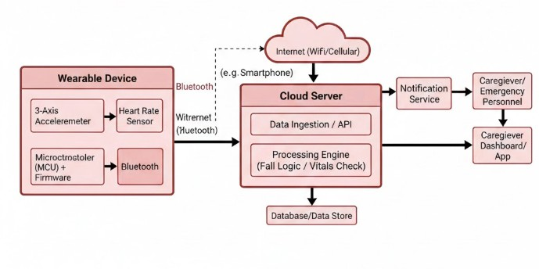

IMPLEMENTATION DETAILS
Fall Confirmation (Accelerometer): A high impact followed by
10 seconds of stillness confirms the fall and triggers a primary alert.
Condition Check (Pulse): 3seconds after the fall, the patient's heart rate is checked. An alert is critically
escalated if the pulse is outside the 50 to 120 BPM

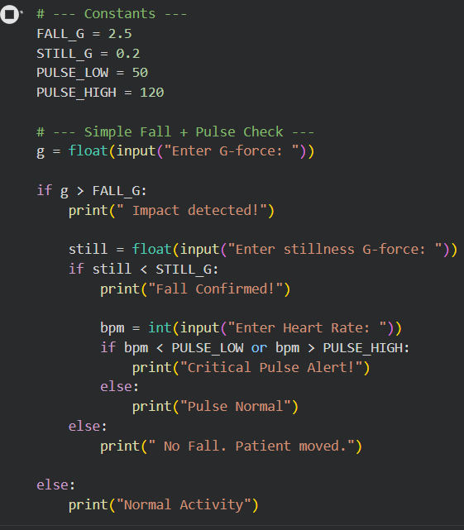

TESTING APPROACH

Unit Testing: Verify individual constants work Integration Testing: Test the full logic flow using simulated data.
System Testing: Test real-world reliability using physical scenarios
(deliberate falls, ADL false alarms) and check alert latency

CHALLENGES FACED

False Alarms: High rate of False Positives (e.g., sitting heavily) and False Negatives (missing slow falls).
Calibration: Fixed thresholds (2.5G) don't adapt to individual patients
or environments.
Power: Continuous monitoring of G-force and pulse is a major battery drain.
Data Quality: Motion artifacts corrupt heart rate data after a fall.
 Compliance: Device must be comfortable for 24/7 wear to be effective.

LEARNING AND TAKEAWAY
Learning: Simple, static thresholds (like 2.5G for impact) are efficient but fundamentally limited. They cannot distinguish between a real, dangerous fall and vigorous everyday activities.
Takeaway: Robust safety systems require adaptive algorithms or
machine learning to minimize false alarms (reducing caregiver "alarm fatigue") while ensuring high sensitivity to genuine falls.

FUTURE ENHANCEMENTS
AI/ML: Implement Adaptive Thresholds to reduce false alarms.
Sensor Fusion: Add Gyroscope and Ambient Sensors for better fall confirmation.
Optimization: Use Edge Computing for better battery life and
integrate with telemedicine.

REFERENCES
- Academic Papers/Articles Referred
- World Health Organization. "Patient safety." WHO Fact
Sheet.
- Oliver D, Healey F, Haines TP. "Hospital Fall Prevention: A Systematic Review of Implementation, Components, Adherence, and Effectiveness." J Am Geriatr Soc. 2013-03-24. https://pmc.ncbi.nlm.nih.gov/articles/PMC3670303/

